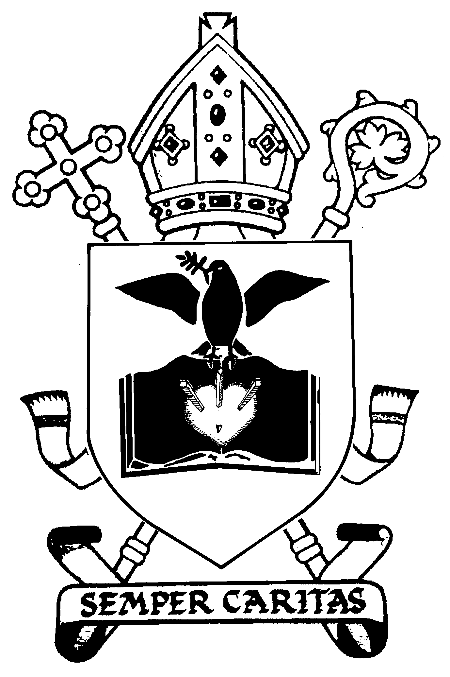
DIOCESE OF DUNKELD
Child Photograph/Video Permission Form

Name of Parish:

We would be grateful if you would fill in this form to give us permission to take photographs of your child and use them on our Parish or Diocese website/ Facebook page, to display in Church, include in a Parish or Diocese publications.

Name of child:

Please tick / delete as appropriate:

- I give permission for a designated person (appointed by the Parish Priest) to take photographs and/or video of my child at parish events and for those images to be used on the Parish or Diocese website/Facebook page, to be displayed in Church and/or included in a Parish or Diocese publications.
- I do not give permission for a designated person (appointed by the Parish Priest) to take photographs and/or video of my child at parish events.
- I give / do not give permission for the first name of my child to be used to identify him/her.
- I reserve the right to request that images are removed if necessary and will do so in writing.

Name of parent guardian:

Signature of parent guardian:

Date:

